Project Design Phase-II Technology Stack (Technology Architecture & Stack)

Date | 15 October 2022
Team ID | PNT2022TMID28577
Project Name | Predicting the energy output of wind turbine based on weather condition
Maximum Marks | 4 Marks

Technical Architecture:
The Deliverable shall include the architectural diagram as below and the information as per the table1 & table 2 Example: Predicting the energy output of wind farm based on weather conditions.
Reference: https://www.mdpi.com/1996-1073/7/6/3900

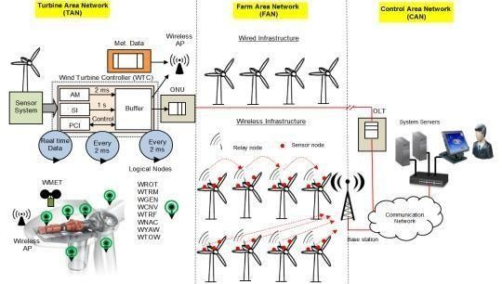
  Guidelines:
  The proposed communication network architecture for the Smart-WPF consists of three networks: the turbine area network (TAN), the farm area network (FAN), and the control area network (CAN). It consists of hierarchical architectures where Level 1 is a sensor network in a single wind turbine, Level 2 is the wind turbine- to-wind turbine interaction in the WPF, Level 3 is the local control center to wind turbine interaction, and Level 4 is the farm-to-farm interaction to optimize grid operation. In order to implement hierarchical network architectures, a hybrid communication solution is considered. EPON-based architecture represents a wired solution, while ZigBee-Pro is considered for the wireless solution. In this work, Levels 1 and 2 are explained in more detail, while Levels 3 and 4 are out the scope of this work.

Table-1 : Components & Technologies:
S.No | Characteristics | Description | Technology
1. | Open-Source Frameworks | The open source framework used in this system is flexible and it includes R, python etc.. | IBM Open source Tools and databases.
2. | Security Implementations | The data stored in the database when shared with industries are encrypted and shared as encrypted data to avoid the access of data by third party people. | SHA-256, Encryptions, IAM Controls, OWASP etc.
3. | Scalable Architecture | The architecture used here is a 3tier architecture where a middleware is present to carry out the communication between client and server. | 3tier architecture.

S.No | Component | Description | Technology
1. | User Interface | This is used by the user for interacting with the system to know about the services provided by system. | HTML, CSS, Angular Js.
2. | Weather Data collector | This weather data collector is used to collect the real time weather data in the environment. | Sensors, wired and wireless network.
3. | Symbolic Regression (Machine Learning Model) | To deal with interaction of the different parameters. | Genetic Programming Data Modeler.
4. | Database | Used to store the collected and examine weather condition and energy output. | MySQL, NoSQL, etc.
5. | File Storage | To store the data files in the databases for future references. | Local or Global File System or IBM Storage.
6. | External API | This application programming interfaces is used to know about the energy output based on every weather condition. | Weather conditions obtained and their energy output.
7. | Infrastructure (Server / Cloud) | The whole system is applied and stored in server for easy access and retrieved. | Data Storage Server or IBM Cloud Servers

Table-2: Application Characteristics:

4. | Availability | The system is designed in a way that It can handle traffic in a better way and thus helps the system available for users at any time. | Network traffic analysis tools.
5. | Performance | The system can efficiently handle a higher number of request and can also uses catch buffer to store and retrieve the data in a easier way. | Methods like Confusion Matrix F1 score, Precision – Recall curve etc.

References:
https://c4model.com/
https://www.mdpi.com/1996-1073/7/6/3900
https://medium.com/the-internal-startup/how-to-draw-useful-technical-architecture-diagrams-2d20c9fda90d

